Assignment 2

USE Company;
SELECT * FROM Department;
SELECT * FROM Employee;
INSERT INTO Employee VALUES (111,'Karan',95000,'2025-02-10',5), (112,'Pooja',72000,'2025-03-15',6), (113,'Arjun',88000,'2025-04-20',7), (114,'Meera',67000,'2025-05-25',8), (115,'Rakesh',54000,'2025-06-05',9);
SELECT Employee_id, Employee_name, Salary, ROW_NUMBER() OVER(ORDER BY Salary DESC) AS Row_Num FROM Employee;
SELECT Employee_name, Salary, CASE WHEN Salary >= 80000 THEN 'High Salary' WHEN Salary >= 60000 THEN 'Medium Salary' ELSE 'Low Salary' END AS Salary_Category FROM Employee;
CREATE VIEW Employee_Details AS SELECT e.Employee_id, e.Employee_name, e.Salary, d.department_name FROM Employee e JOIN Department d ON e.Department_id = d.department_id;
SELECT * FROM Employee_Details;
CREATE TABLE Employee_Log(Log_ID INT AUTO_INCREMENT PRIMARY KEY, Employee_ID INT, Action_Type VARCHAR(20), Action_Time TIMESTAMP DEFAULT CURRENT_TIMESTAMP);
Q1 :- Added data
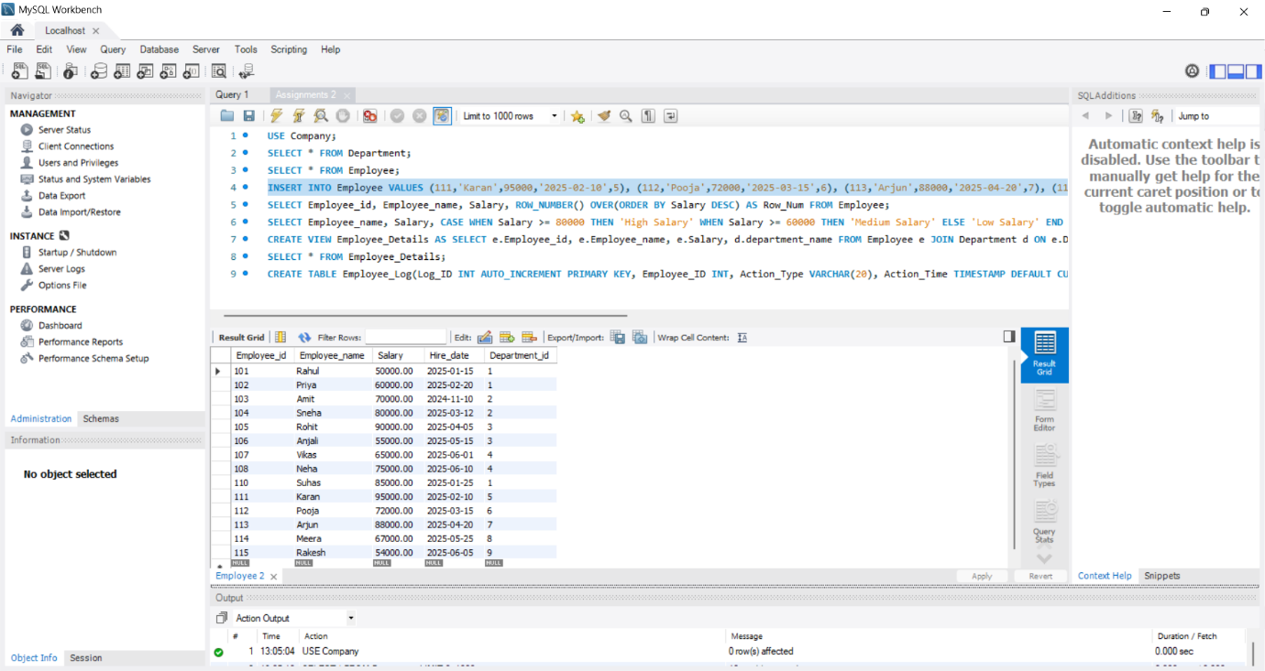
Q2:- Window Function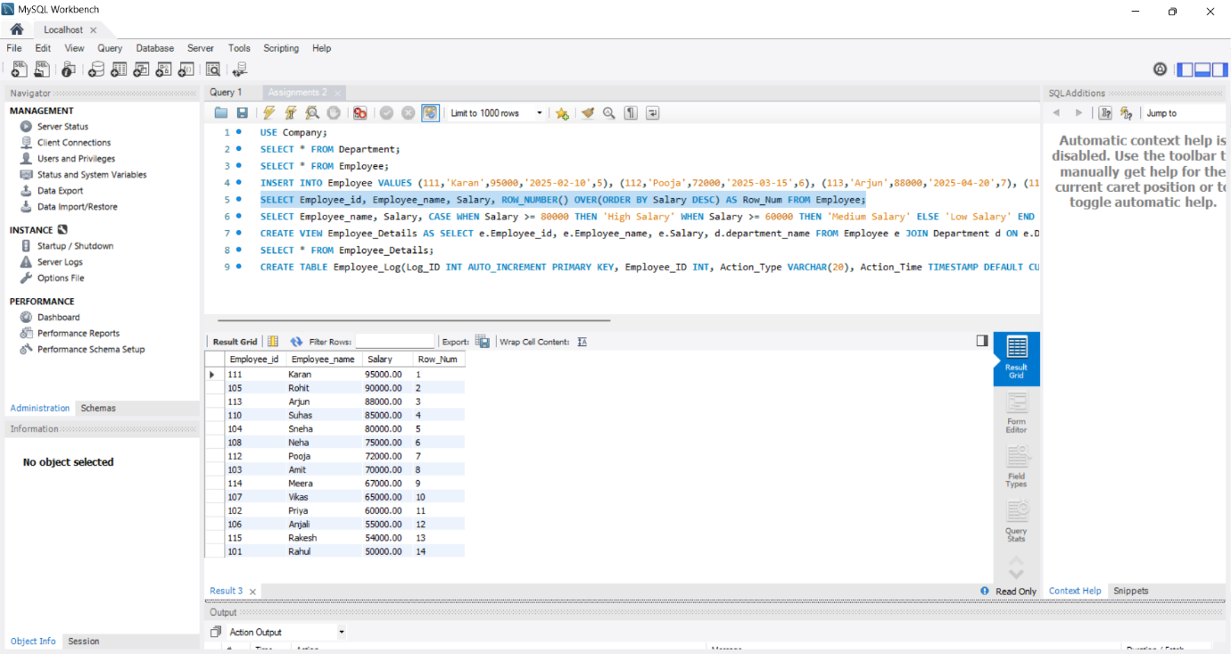

Q3:- Case when
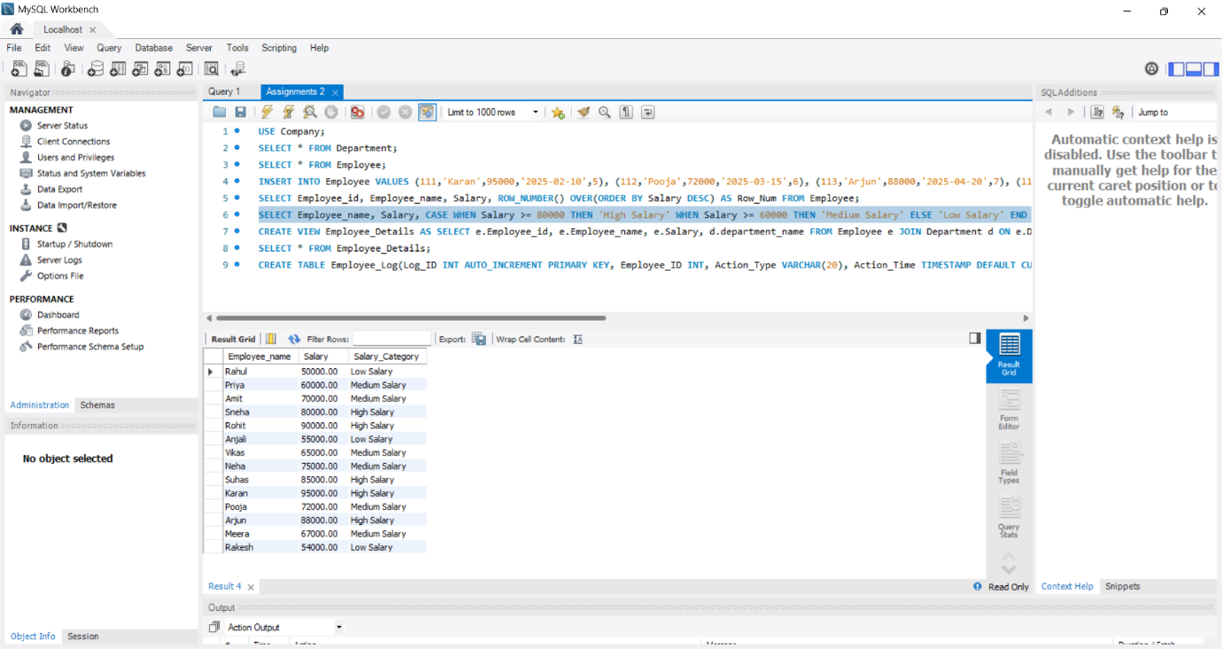

Q4:-Views
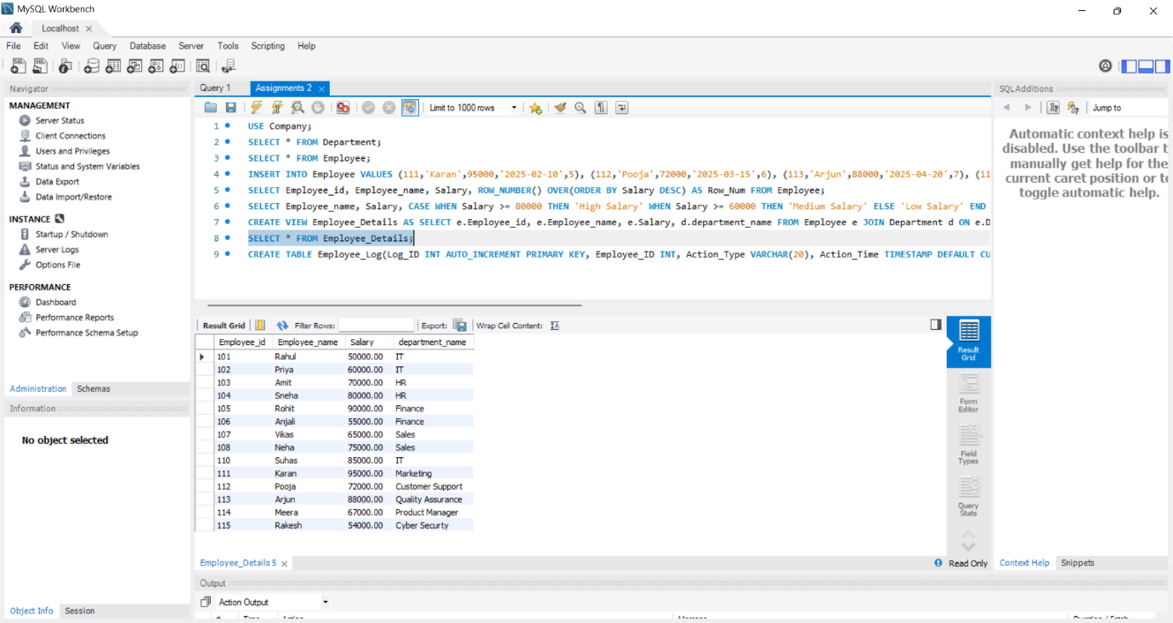

Q5:-Trigger
